Program Chair Monthly Report
September 2023

On behalf of the Executive Committee and your facet chairs, I’m happy to serve for the next biennium in the programming role.
For the new links, each chapter is required to complete an annual programming report. We do so for three reasons:
- To ensure and document that Links are fulfilling their legal and constitutional responsibilities
- To demonstrate our value with partner organizations in communities across the globe, and
- To assess our effectiveness in programming
The period we report on is from May 1 to April 30 and the report is due on February 1st … which means for me it’s due and submitted by January 30!
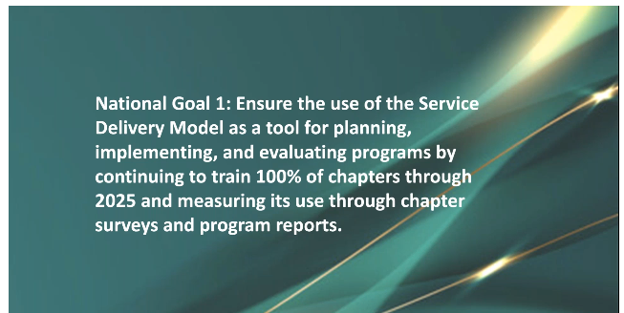
Also continuing by way of our process is our use of the Service Delivery Model (SDM) with its 6 planning elements as a tool for planning, implementing and evaluating programs by continuing to train 100% of chapters through 2025. The organization will measure SDM use through chapter programs and reports.
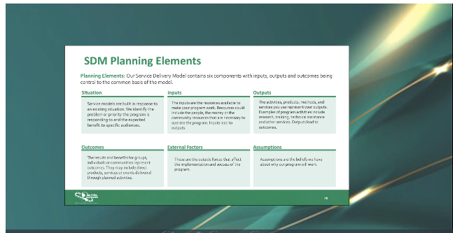
Chapters have the option to implement Single Facet Programming, (which the Western area does not encourage) Integrated Programming (3 facets) or Umbrella programming (all 5 facets) which is what Tacoma chapter has done for quite some time, and the area encourages this due to the area’s administrative theme: “Linked to Connect, Create, and Collaborate.” Programs should fit with the menu of our organization’s 29 national programs: National Signature, National Initiatives, National Priority, National Pilot and National Supporting.
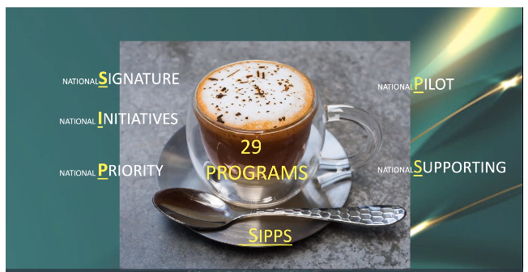
Certainly we don’t do what we do for the awards, but rather for those we serve. Awards are affirmations of our processes, our results and/or our best practices. Last year, our chapter was awarded a 2nd place prize in the arts … well earned and well deserved. We may very well be contacted for collaboration, as the WA Arts Facet Chair is Link Carmen Mayo out of the Seattle Chapter.
But I do want to make sure that I’m transparent: our programming can increase our chances of earning awards money at the next assembly.
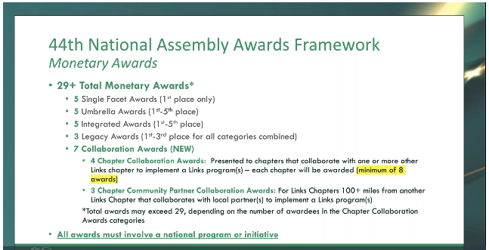
This year, as we’re already finalizing our activities, programs and work around the umbrella program “Linking the Community to a Brighter Future,” I’m certain given today’s news that we will once again see the arts heavily featured and interconnected, as art and its impacts in the communities we serve should not be underestimated. I’m looking forward to all that we’ll do together.
Earlier this month the Western Area shared a Program webinar. Madam president has shared it with me, and I have shared it with the facet chairs for review with their committees. A few of the slides here came from that webinar. But in order to keep this short and sweet so we can get on to the facet’s short and sweet reports, let’s get some National Impact Days on the calendar for us to consider how we might program and engage in order to align.
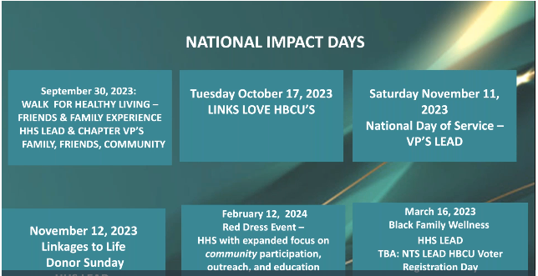
September 30, 2023 Walk for Healthy Living (HHS Lead)
October 17, 2023 Links Love HBCU’s
November 11, 2023 National Day of Service
November 12, 2023 Linkages to Life/Donor Sunday (HHS Lead)
February 12, 2024 Red Dress Event (HHS Lead)
March 16, 2024 Black Family Wellness (HHS Lead)

In addition, there are some International Days to consider:
October 11, 2023 International Day of the Girl
March 8, 2024 International Women’s Day
With that sister links, we’re going to now hear from each of our facets and we’ll hear from them in alphabetical order. They will talk about upcoming service and activities, and briefly recap any activities that have occurred in this program year.
Arts
Health and Human Services
International Trends and Services
National Trends and Services
Services to Youth

