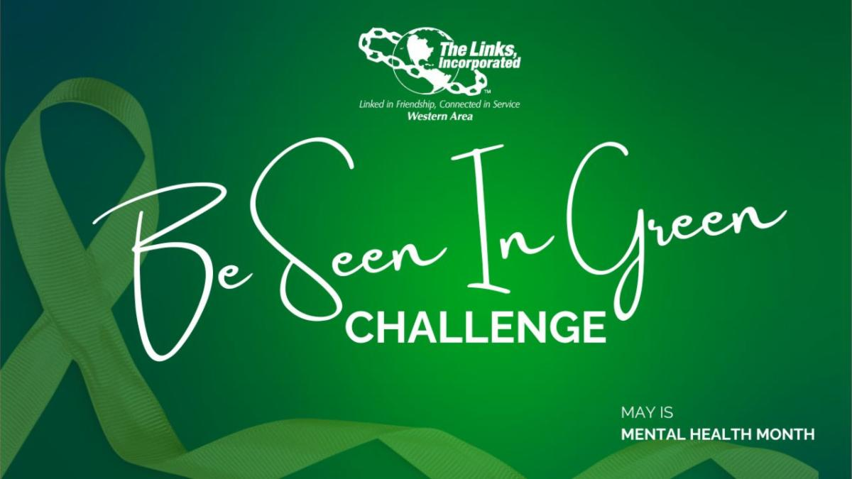

President’s Report: May 2024
Tacoma (WA) Chapter
The Links, Incorporated

Greetings Link Sisters:

Seeing so many at the April Chapter meeting and May Induction was a real treat! I am grateful for your commitment to the chapter and look forward to seeing us expand our time and attention in meeting the needs of the communities we serve.

As we begin a new Program Year, I am working to refine how we collect and distribute information more efficiently. I also scheduled Executive Committee meetings, held a mini orientation for new officers, consulted with the Western Area Director and Vice Director, responded to emails, telephone calls, and text messages, and attended WA webinars. I am also working on handbook revisions, firming up appointments, strategizing with the Program Chairs, developing an event planning guide/checklist, composing thank-you letters for donors and partners, creating a process to distribute the chapter photos, and preparing for the National Assembly.
The 44th National Assembly will convene at the Gaylord Texan Resort. Link Stephanie McGriff and I are excited to represent the chapter.
All in all, our intergenerational chapter is growing and positioned to elevate our local and global impact through programming, friend- and fund-raising. Your input is essential, and I recommend we come together for a Planning Retreat on Saturday, July 27 at 9:30 am, at the University of Washington Tacoma.

Well, that’s all for now. Take care and feel free to call or email me if you have questions.

Sisterly,
Link Mentha

“Friendship and service are to The Links, Incorporated,
what water and sunshine are to plants.”
– author unknown
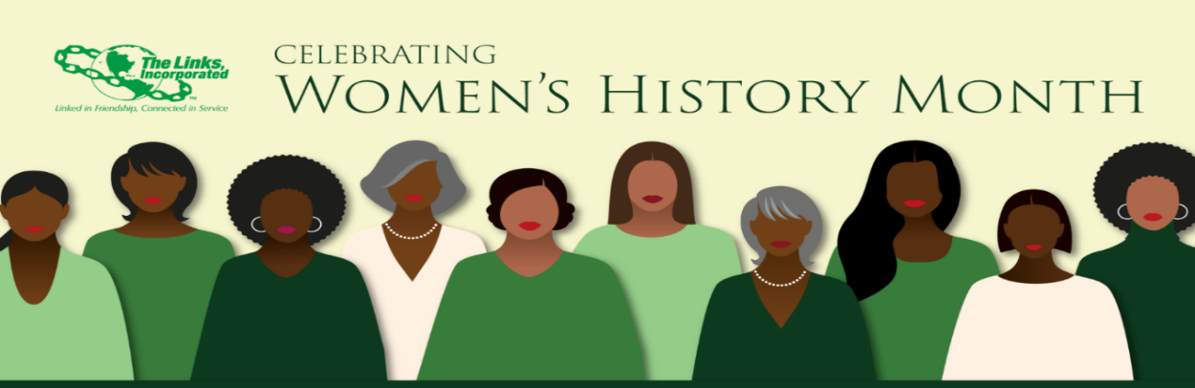
The Links, Incorporated | Tacoma (WA) Chapter | Executive Leadership Planning Meeting
Saturday, April 13, 2024
Goals for the day
- Link up with new officers and begin to nurture teamwork.
- Explore roles and goals.
- Consensus on the common issues and priorities for the next six months.

Topic 1: Become acquainted with each other and familiar with goals and roles.
Topic 2: Chapter SWOT and shared expectations.
Topic 3: Retreat Date + Tasks and Timelines to discuss with the Chapter

For Consideration: April Transition and Information Gathering

May Induction
Fundraiser

June NO MEETING
Social – postponed per Link Kay
National Assembly: 19 - 24

July Retreat - - -
Voter registration + HBCU Giving + Building STEAM Leadership Development and Mentoring + Individual and Collective Wellness + The Arts + Youth In Law + Fundraising + Friend raising + Web refresh

August Finalize Program Theme + Dates, Details, Media, and Budget
Connecting Link Happy Hour

September Ready. Set, Go.
STEAM Tacoma Leadership Development and Mentoring
Individual and Collective Wellness

October Youth and Law
Membership Audit

November Friendship Month
Building STEAM Tacoma Leadership Development and Mentoring
The Arts
National Day of Service

